***PAAREES PERFUMES***

***VERSACE***

***FOR UNISEX***

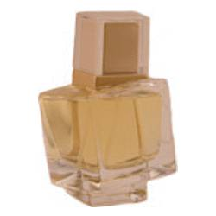

# 

# *V_e Versace*

## *Description:*

V'e Versace by Versace Perfume. Created by the fragrance design experts at Versace in 1989, V'e Versace is a delightful scent for the discriminating woman. This versatile fragrance combines the sweetness and fruit essences of African orange flower, bergamot and Amalfi lemon with the balancing of subtle green notes to create a scent that moves with ease from the calmness of the office to the excitement of the dance floor. Enjoy the womanly confidence that comes with wearing the rich, fruity notes of V'e Versace.